## Clarification

### Simplification

#### Definition:

Reduces the complexity or breadth of discussion. This edit might also remove information from the article.

#### Example:

http://localhost:5002/check_task?source=ap&doc_id=12111&v_x=0&v_y=1

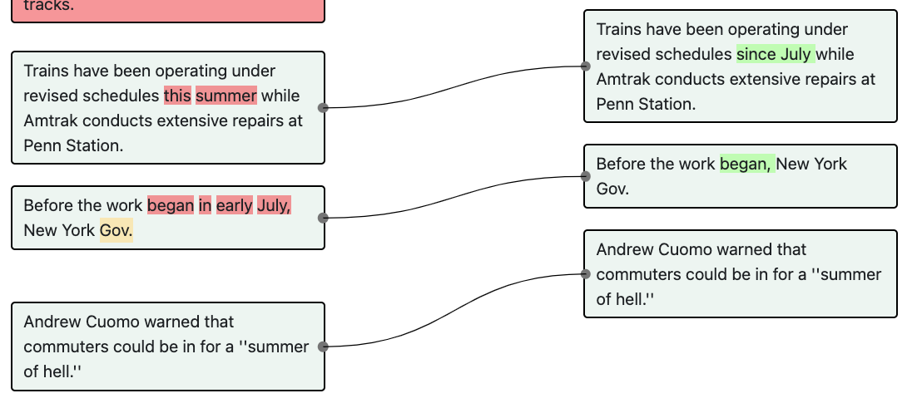

```Before the work began in early July, New York Gov. ||| Before the work began, New York Gov.```

##### Explanation:

“In early July” is removed because July has been mentioned in the previous sentence. Hence, it is being simplified for clarification. This is not <b>Emphasizing a fact</b> because no text is added. Neither is it a <b>Preferential Edit</b> because the edit only involves deletion of texts instead of different word choices.

### Define term

#### Definition:

The author provides <i>meaning</i> or <i>differentiation</i> to a term or concept that might be unknown to the reader. Note that this intention is DIFFERENT from the <b>Background</b> intention, which is more about providing <i>context</i>, e.g. historical or geographic context for a person, company, or place.

#### Example:

mRNA vaccines are the dominant approach to COVID-19 vaccination in the U.S. ||| mRNA vaccines, which use protein-encoding messenger RNA to tell the body how to produce specific proteins associated with a virus, are the dominant approach to COVID-19 vaccination in the U.S.

##### Explanation:

### Emphasize a Point

#### Definition:

The journalist expands or changes the sentence to highlight a fact or argument but does not introduce additional background or analytical information.

#### Example:

http://localhost:5002/check_task?source=bbc&doc_id=557714&v_x=0&v_y=1

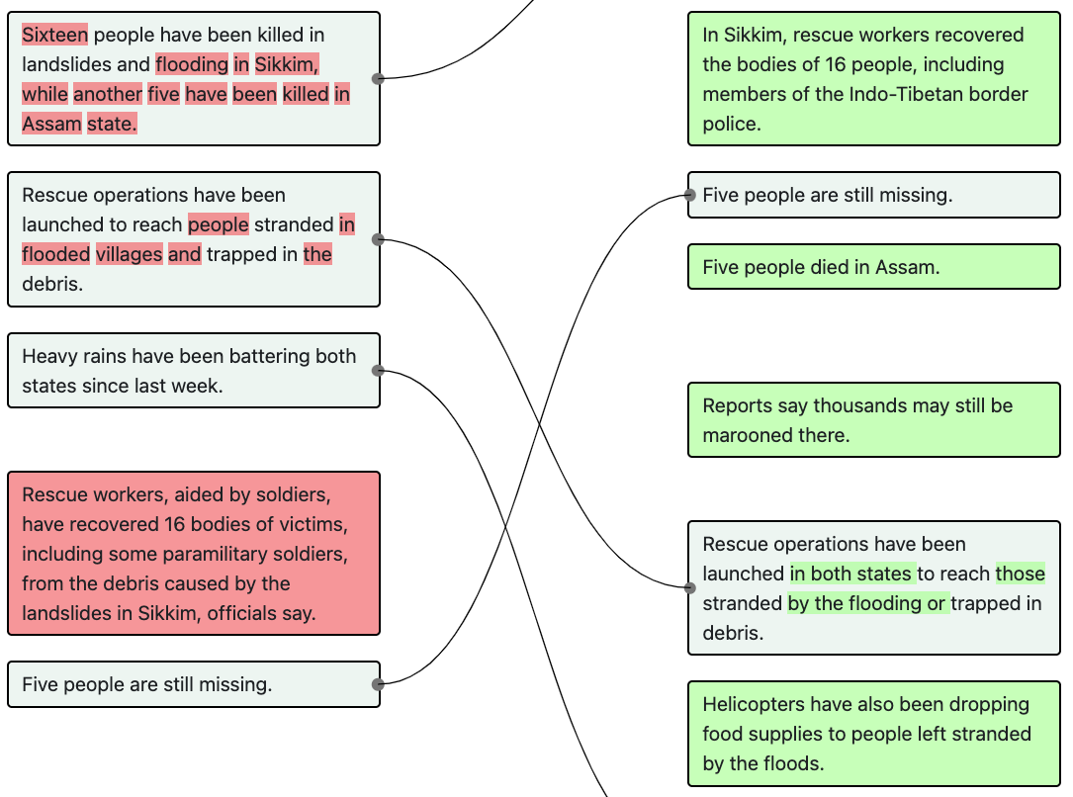

```Rescue operations have been launched to reach people stranded in flooded villages and trapped in the debris. ||| Rescue operations have been launched in both states to reach those stranded by the flooding or trapped in debris.```

##### Explanation:

This edit is <b>Emphasizing a fact</b> because it attempts to clarify the launching location (i.e. “in both states”). It is not a <b>Background</b> because “in both states” is not new information, but information that is ignored or assumed to be known in the first version. It also involves <b>Preferential Edit</b> because the latter part of the sentence has been refactored. It is not a <b>Style-guided Edit</b> because the refactoring is not fixing violations of style guides.

### Sensitivity Consideration

#### Definition:

The journalist rewrote the sentence because the original version is inappropriate/ may be considered insensitive.

#### Example:

http://localhost:5002/check_task?source=independent&doc_id=976785&v_x=0&v_y=1

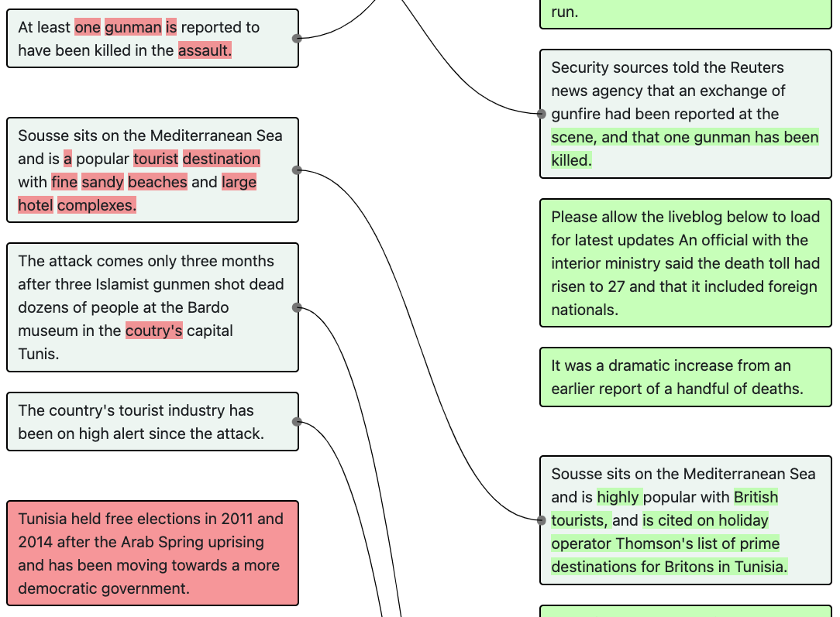

```Sousse sits on the Mediterranean Sea and is a popular tourist destination with fine sandy beaches and large hotel complexes. ||| Sousse sits on the Mediterranean Sea and is highly popular with British tourists, and is cited on holiday operator Thomson's list of prime destinations for Britons in Tunisia.```

##### Explanation:

The article is about an attack that leads to deaths in Sousse but the first version describes how good the beaches are, which is inappropriate given the tragic nature of the incident being described.

## Copy Editing

### Style-guide Edits

#### Definition:

Edits that are made specifically to address a formal style guide (when in doubt, defer to the Associated Press style-guide). The first version violates the style guide and the revised version fixes it.

#### Example:

http://localhost:5002/check_task?source=nyt&doc_id=1870033&v_x=0&v_y=1

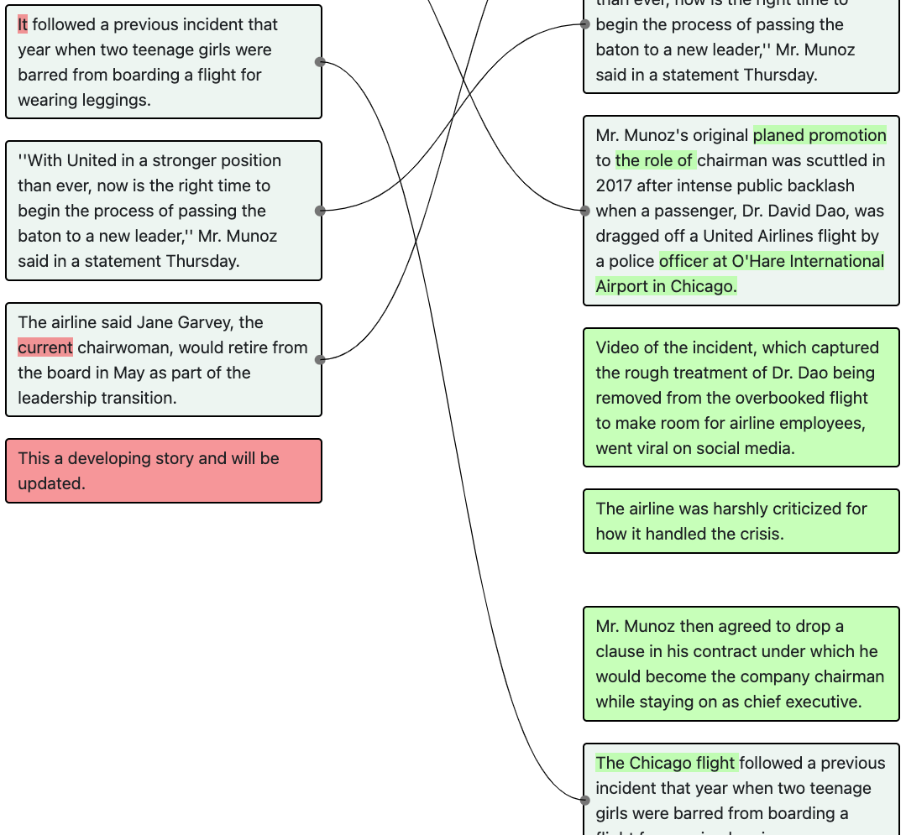

```It followed a previous incident that year when two teenage girls were barred from boarding a flight for wearing leggings. ||| The Chicago flight followed a previous incident that year when two teenage girls were barred from boarding a flight for wearing leggings.```

##### Explanation:

In the first version, the journalist uses “It” to refer to “The Chicago flight”, which was not mentioned prior in the article, which violates the style guide. This edit is not a <b>Preferential Edits</b> because the edit does fix a style guide violation. Thus the explicit violation takes precedence over any personal or artistic preference from the journalist or copy-editor.

### Tonal Edits

#### Definition:

The journalist or copy-editor made the edits due to a specific personal or artistic preference. Use your intuition here: these are usually edits that introduce punch, elegance or scenery. These edits often <i>also</i> have the effect of some other edit-intention, see the example, but cannot be fully ascribed to other aims.

#### Example:

http://localhost:5002/check_task?source=nyt&doc_id=1870033&v_x=0&v_y=1

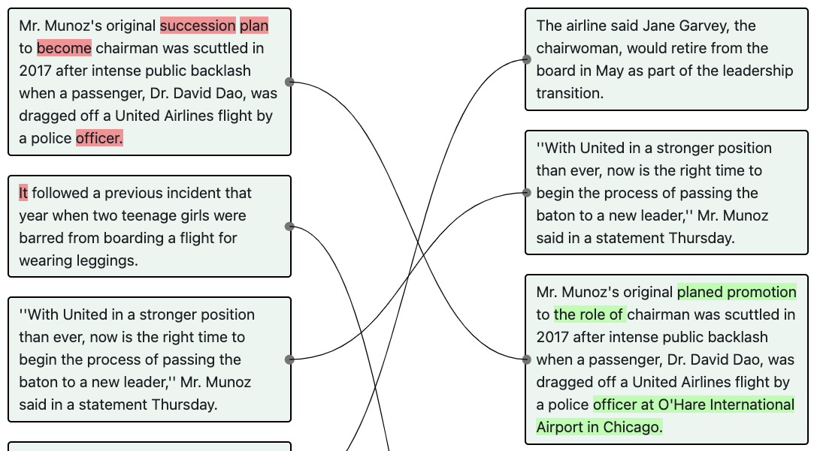

```Mr. Munoz's original succession plan to become chairman was scuttled in 2017 after intense public backlash when a passenger, Dr. David Dao, was dragged off a United Airlines flight by a police officer. ||| Mr. Munoz's original planed promotion to the role of chairman was scuttled in 2017 after intense public backlash when a passenger, Dr. David Dao, was dragged off a United Airlines flight by a police officer at O'Hare International Airport in Chicago.```

##### Explanation:

Here the use of “succession plan” and “become” does not violate any style guidelines or grammar. Hence, this edit is not a <b>Style-guided Edit</b> or <b>Syntax Correction</b>, but a <b>Preferential Edit</b>. The edit also involves <b>Emphasizing a Point</b> as the journalist attempts to clarify where the officer is from, at the end of the sentence. In this case, we would annotate with two intentions by clicking the “+” button to add a second intention dropdown.

### Syntax Correction

#### Definition:

Improve grammar, spelling, or punctuation. These are strictly to correct errors in syntax, not <b>Preferential Edits</b>. And, they need not be adhering to a formal style-guide (when a <b>Syntax Correction</b> is <i>also</i> adhering to a <b>Style Guide</b>, please use the “+” button to add another intention dropdown and annotate both).

#### Example:

http://localhost:5002/check_task?source=bbc&doc_id=372407&v_x=2&v_y=3

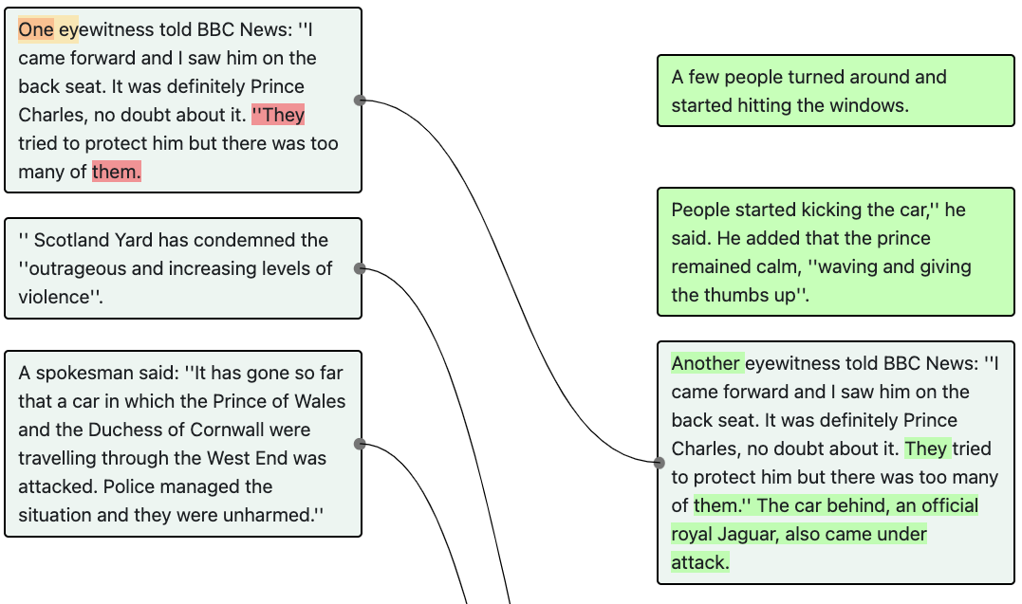

```One eyewitness told BBC News: ''I came forward and I saw him on the back seat. It was definitely Prince Charles, no doubt about it. ''They tried to protect him but there was too many of them. ||| Another eyewitness told BBC News: “I came forward and I saw him on the back seat. It was definitely Prince Charles, no doubt about it. They tried to protect him but there was too many of them.” The car behind, an official royal Jaguar, also came under attack.```

##### Explanation:

This is a <b>Syntax Correction</b> because in the first version, “They tried to protect him but there were too many of them.” is mistakenly being included as part of the quote, which is fixed in the second version. This is not a <b>Preferential Edit</b> or a <b>Style-guided Edit</b> because the rest of the sentence is not refactored and the edit does not attempt to fix a violation of style guidelines.

## Elaboration

### Background

#### Definition:

Add additional contextualizing information to the article to help readers understand the history, geography or significance of a term, personal, place or company. Note that contextualizing information is <i>not</i> analysis, expectations, or projections, which would fall into the <b>Analysis</b> intention category.

#### Example:

http://localhost:5002/check_task?source=independent&doc_id=976785&v_x=0&v_y=**1**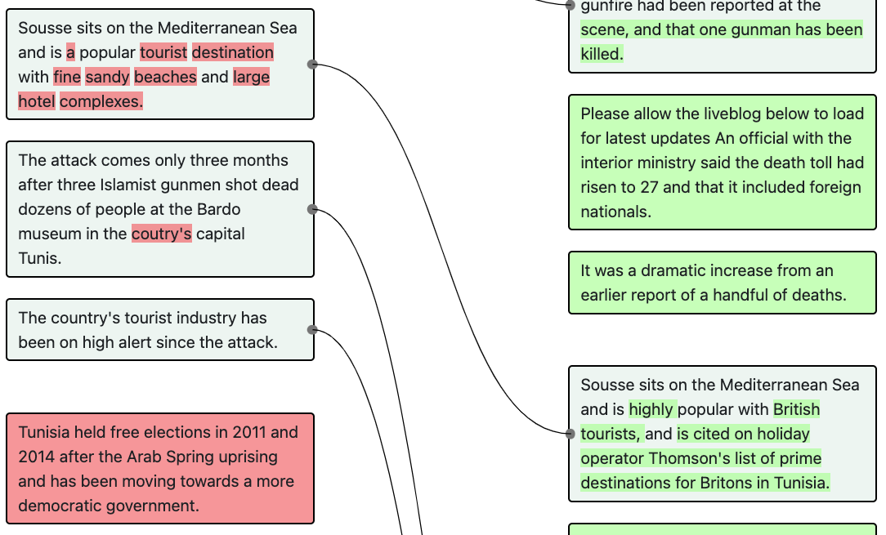

```“Sousse sits on the Mediterranean Sea and is a popular tourist destination with fine sandy beaches and large hotel complexes.” ||| “​​Sousse sits on the Mediterranean Sea and is highly popular with British tourists, and is cited on holiday operator Thomson's list of prime destinations for Britons in Tunisia.”```

##### Explanation:

In this example, the author provides additional information about ​​Sousse. Hence, the edit is an Elaboration - Background. It is not an Elaboration - Analysis because the new information introduced is not analysis derived from/ inferred by the journalist.

#### Example:

http://localhost:5002/check_task?source=nyt&doc_id=1870033&v_x=0&v_y=1

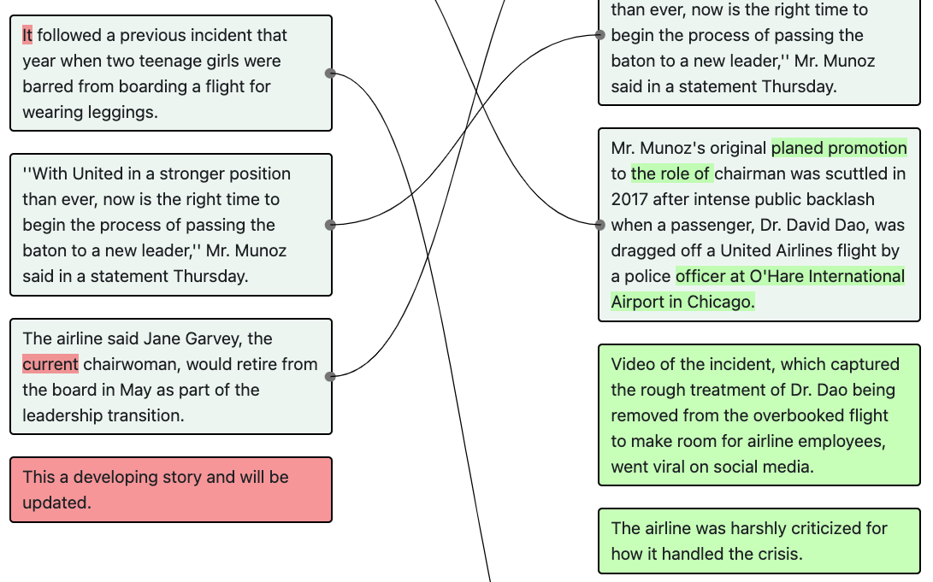

```|||Video of the incident, which captured the rough treatment of Dr. Dao being removed from the overbooked flight to make room for airline employees, went viral on social media. “The airline was harshly criticized for how it handled the crisis.”```

##### Explanation:

The article is breaking news. These new edits provide more additional information about the event. Hence, the edit is an <b>Background</b>. It is not an <b>Analysis</b> because the new information introduced is not analysis derived from/ inferred by the journalist.

### Analysis

#### Definition:

The writer adds meaningful inferences from the presented information. These can be in the form of analyses, expectations, or deeper understandings. These are usually forward-looking rather than <b>Background</b> information, which is usually past-looking.

#### Example:

http://localhost:5002/check_task?source=ap&doc_id=459&v_x=6&v_y=7

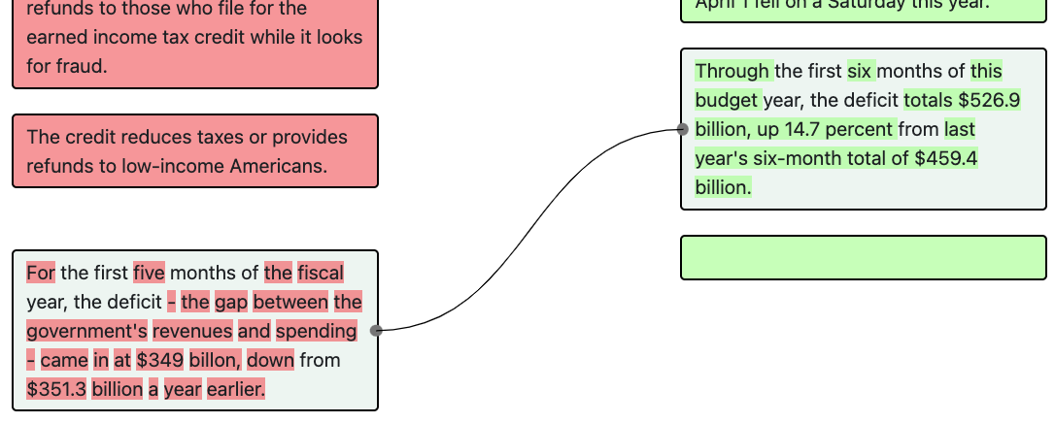

```For the first five months of the fiscal year, the deficit - the gap between the government's revenues and spending - came in at $349 billon, down from $351.3 billion a year earlier. ||| Through the first six months of this budget year, the deficit totals $526.9 billion, up 14.7 percent from last year's six-month total of $459.4 billion.```

##### Explanation:

This edit is an <b>Analysis</b> because “up 14.7 percent” is the analysis made by the journalist. This is also an <b>Background</b> because the new version includes additional information about the deficit through the first six months which is not mentioned in the previous version. Additionally, this edit involves <b>Deletion with Addition</b> as we see that the deficit for the first five months is removed from the first version because the new version talks about deficit for the first six months. In this case, we use the “+” button to add multiple additional intention drop-downs.

### Update Eye-Witness Account

#### Definition:

The writer adds some color to expand the events being describe. This can either take the form of a quote (in which case this edit should be paired with a <b>Quote Update</b>), or a first-person account by the journalist.

## Fact Update

### Event Update

#### Definition:

There is a change to some event in the world that the article covers and the article needs to be updated to reflect this. Usually, there are changes to the verbs in the article, but this can also include increased death counts, stock-market changes, etc.

#### Example:

http://localhost:5002/check_task?source=nyt&doc_id=1274421&v_x=0&v_y=1

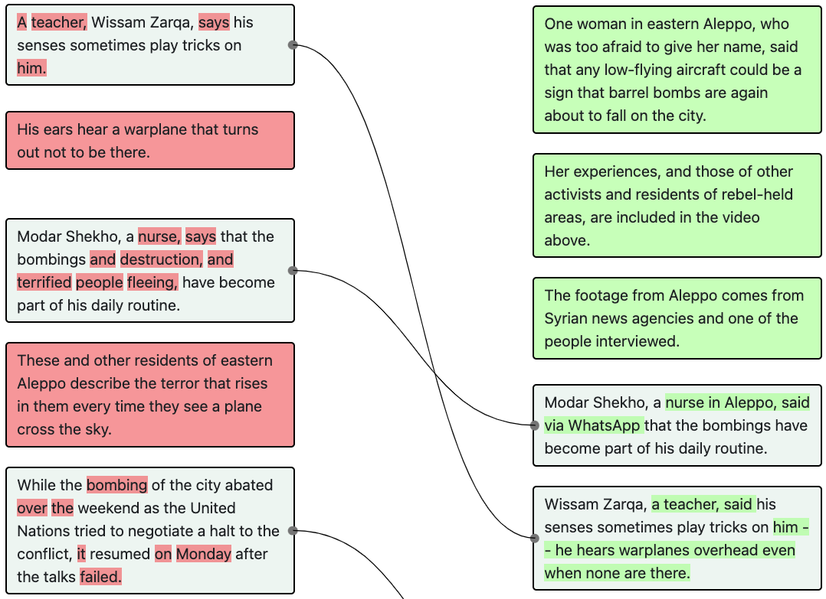

```A teacher, Wissam Zarqa, says his senses sometimes play tricks on him. ||| Wissam Zarqa, a teacher, said his senses sometimes play tricks on him -- he hears warplanes overhead even when none are there.```

##### Explanation:

This edit is an <b>Event Update</b> because we see that the tense is changed from present tense to past tense (says -> said). In addition, it also involves <b>Preferential Edits</b> (because the sentence is refactored) and <b>Background</b> (because additional non-analytical information about how Wissam’s senses play tricks on him is elaborated).

#### Example:

http://localhost:5002/check_task?source=bbc&doc_id=557714&v_x=0&v_y=1

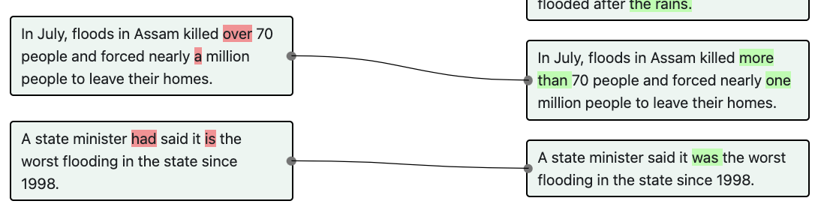

```A state minister had said it is the worst flooding in the state since 1998. ||| A state minister said it was the worst flooding in the state since 1998.```

##### Explanation:

There is a change in the sentence’s tense (from past perfect tense to past tense). It does not involve <b>Preferential Edits</b> because the sentence structure is largely the same. It also does not involve any <b>Elaboration</b> intention because no additional information is introduced.

### Quote Update

#### Definition:

There is an addition, editing or expansion of quotes in the article. Or, a quote from one person is swapped for a quote from another. Sometimes these updates are made with other intentions (e.g. to include a punchier quote, in which case it would also be a <b>Preferential Edit</b>. In these cases, please use the “+” button to add another intention dropdown.)

#### Example:

http://localhost:5002/check_task?source=bbc&doc_id=372407&v_x=2&v_y=3

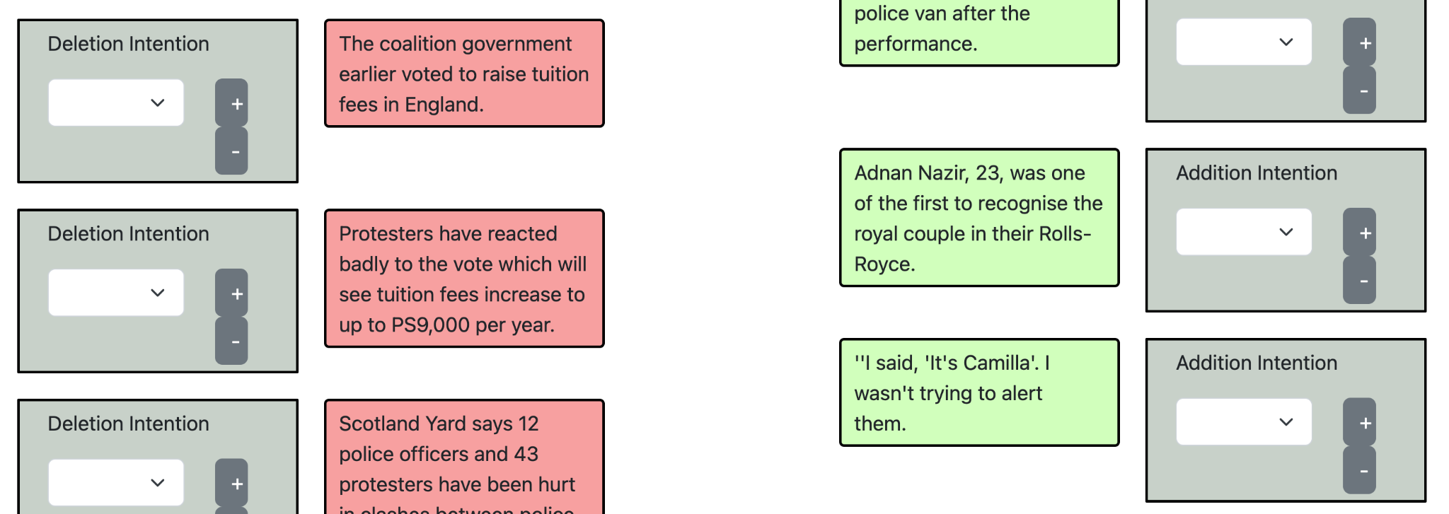

```||| ''I said, 'It's Camilla'. I wasn't trying to alert them.```

##### Explanation:

This edit is a <b>Quote Update</b> because a quote is added. This is also an <b>Background</b> because the quote itself can be viewed as new information introduced and the information is not analytical.

#### Example:

http://localhost:5002/check_task?source=bbc&doc_id=372407&v_x=2&v_y=3

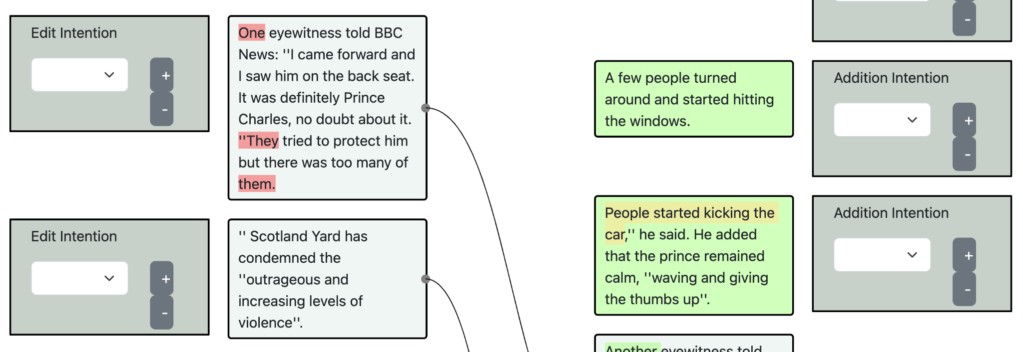

```||| People started kicking the car,'' he said. He added that the prince remained calm, ''waving and giving the thumbs up''.```

##### Explanation:

This edit is a <b>Quote Update</b> because a quote is added. This is also an <b>Background</b> because the quote itself can be viewed as new information introduced and the information is not analytical.

### Source-Document Update

#### Definition:

Additional written documents have been released by a government or company that warrant inclusion/reference in the article. For example, additional information included in an SEC filing, quarterly earnings report, IPCC report, etc.

## Verification

### Correction

#### Definition:

There are <i>factual</i> errors in the original version. The new version corrects the error.

#### Example:

http://localhost:5002/check_task?source=bbc&doc_id=842813&v_x=2&v_y=3

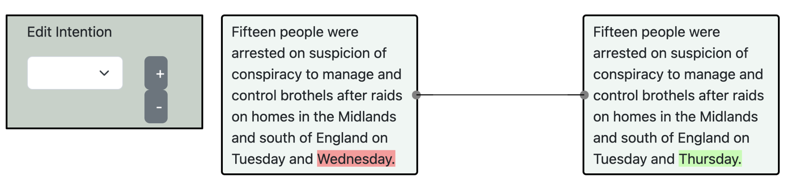

```Fifteen people were arrested on suspicion of conspiracy to manage and control brothels after raids on homes in the Midlands and south of England on Tuesday and Wednesday. ||| Fifteen people were arrested on suspicion of conspiracy to manage and control brothels after raids on homes in the Midlands and south of England on Tuesday and Thursday.```

##### Explanation:

The original version states “Tuesday and Wednesday”, which is corrected to “Tuesday and Thursday” in the next version. This is not a Fact Update because the information is inaccurate in the first version.

#### Example:

http://localhost:5002/check_task?source=bbc&doc_id=1095119&v_x=2&v_y=3

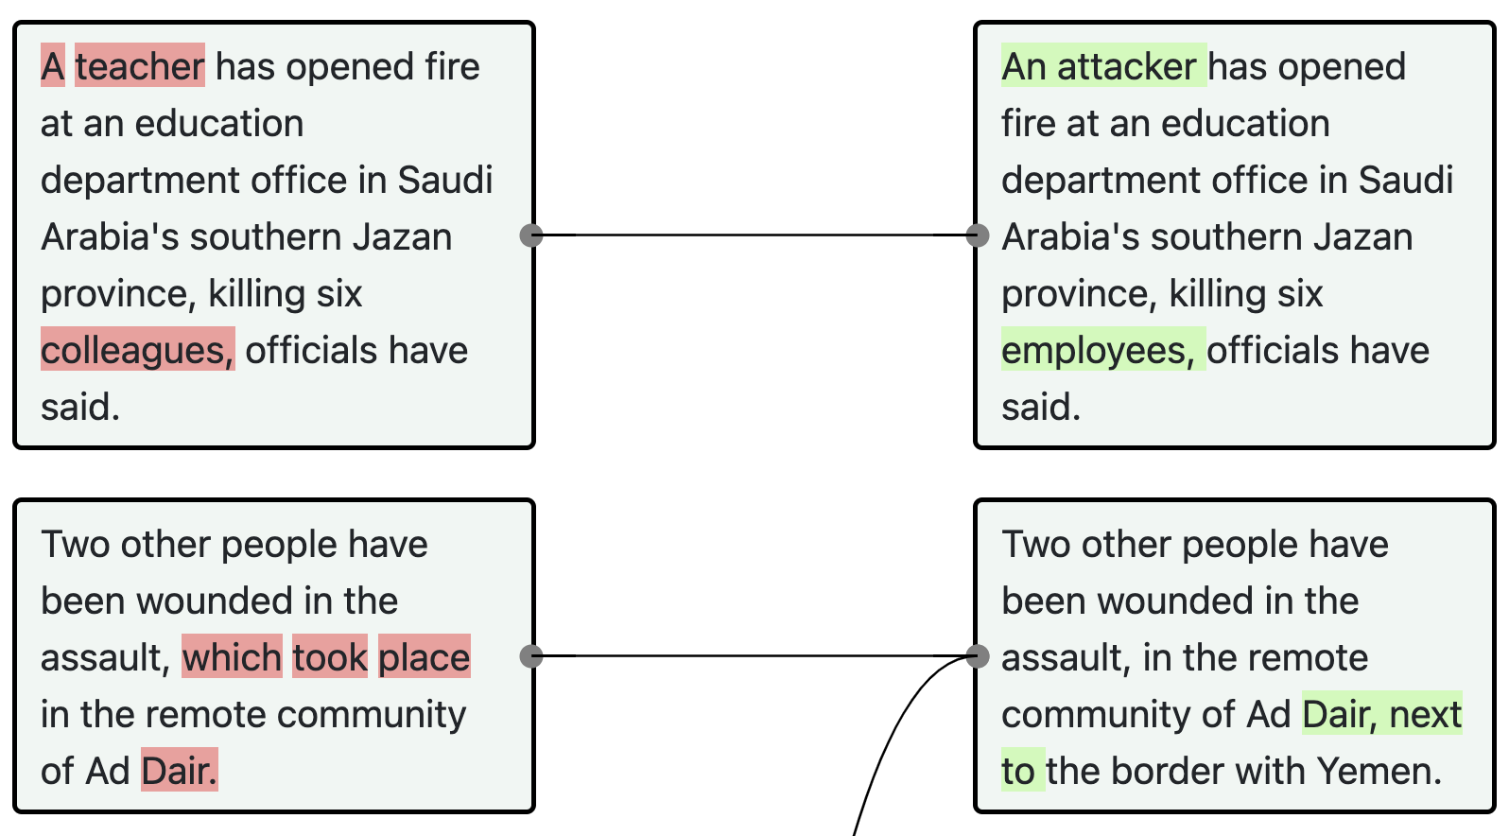

```A teacher has opened fire at an education department office in Saudi Arabia's southern Jazan province, killing six colleagues, officials have said.```

##### Explanation:

In the updated version, we see that we are not 100% sure the suspect is a teacher. Hence a <b>Correction</b> edit.

### Additional Sourcing

#### Definition:

The new version includes evidence of new sources for additional information, usually added for confirmation purposes. Note that this is different from <b>Quote Update</b> or <b>Document Update</b> since <b>Additional Sourcing</b> doesn’t have to result in a new quote or document reference. Can simply be an indication that the journalist obtained new evidence.

## Moved Intentionally

### Emphasize Importance

#### Definition:

The sentence is moved up or down in the document in order to make the sentence MORE prominent, or to emphasize it’s connection to the events being described in another sentence.

### De-emphasize Importance

#### Definition:

The sentence is moved up or down in the document in order to make the sentence LESS prominent, or to de-emphasize it’s connection to the events being described in other sentences.

## Other

### Error: Missing Link (Please Specify)

#### Definition

This refers to an error in our original linking of sentences. We have failed to link a sentence in one version of the article to a sentence in the other version of the article.

Links can be missing <i>from</i> any sentence-type <i>to</i> any other sentence-type: a `Addition`, a `Deletion`, an `Edit` or an `Unchanged` sentence.

A `Deletion` sentence should be linked to an `Addition` sentence if they play the same factual, semantic or discursive role between article-versions. Note that we detect links by looking at word-overlap, so if we’ve missed a link, it’s probably because the wording is substantially different.

If you identify a <b>Missing Link</b>, please annotate both (A) the index of the sentence in the other version that it should be linked to via the dropdown (B) any other intention ascribed to this pair (i.e. Fact Deletion).

#### Example:

http://localhost:5002/check_task?source=ap&doc_id=9984&v_x=0&v_y=1

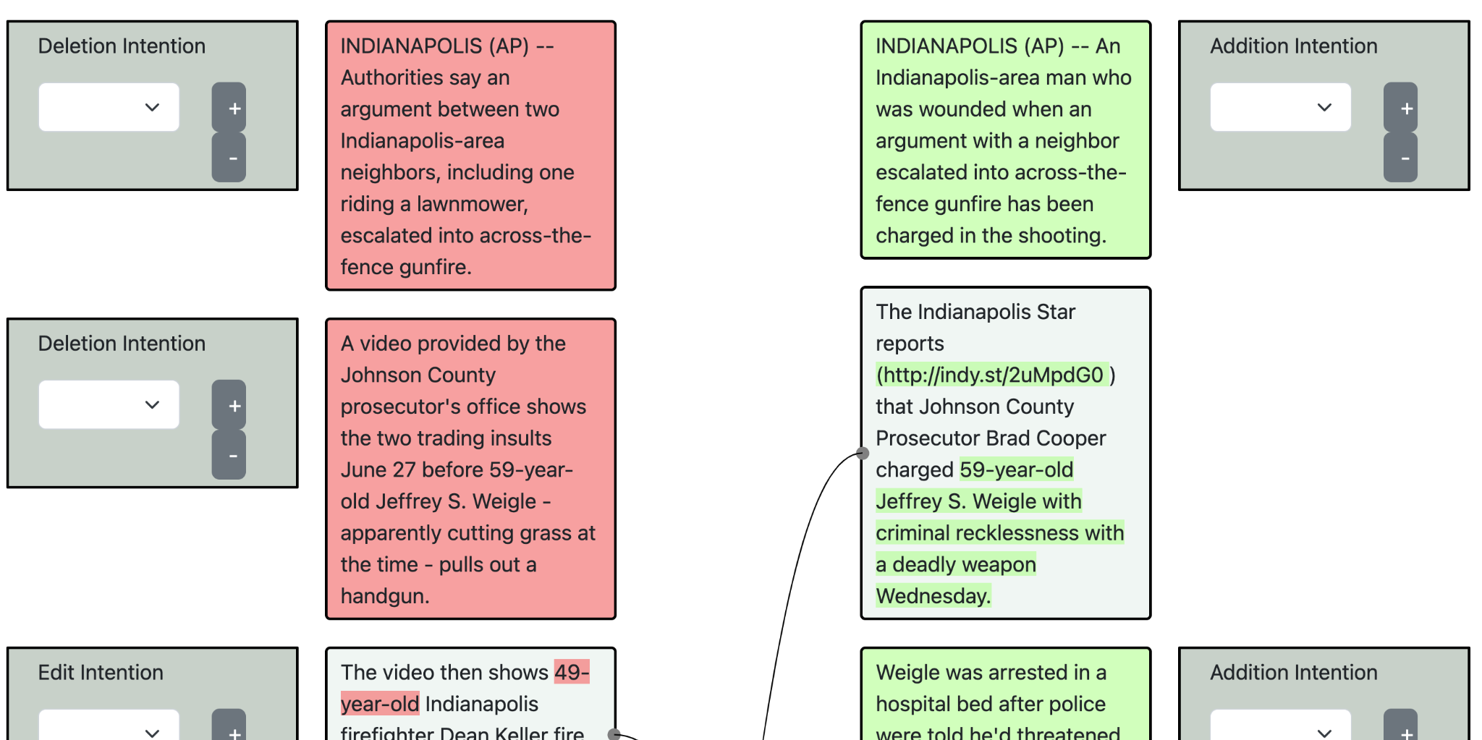

```INDIANAPOLIS (AP) -- Authorities say an argument between two Indianapolis-area neighbors, including one riding a lawnmower, escalated into across-the-fence gunfire. |||```

##### Explanation:

The first sentence in the old version should be linked to the first sentence in the new version because they both convey the same main event. However, it was substantially updated and reworded because the writer now has more information about the event (e.g. one man is wounded). Thus, <b>Missing Link</b> should be noted as the first intention, and <b>Event Update</b> should be paired in the second.

### Error: Incorrect Link (Please Specify)

#### Definition

This refers to an error in our original linking of sentences. We have linked two sentences that should NOT be linked.

This only pertains to `Edit`ed or `Unchanged` sentences. Sentences should not be linked if they are entirely unrelated — they have substantially different syntax, intent, and purpose — and, by error, our algorithm said they were.

If you identify an <b>Incorrect Link</b> AND there are more than one links, please specify (A) the index of the sentence in the other version that it should NOT be linked to via the dropdown (B) any other intention ascribed to this pair (i.e. Fact Deletion).

### 

### Other (Please Specify)

#### Definition

Any edit made that doesn’t neatly fit into the categories expressed above. In these cases, please also elaborate on the supposed intention behind this edit in the textbox that appears.

#### Example:

http://localhost:5002/check_task?source=ap&doc_id=1129&v_x=3&v_y=4

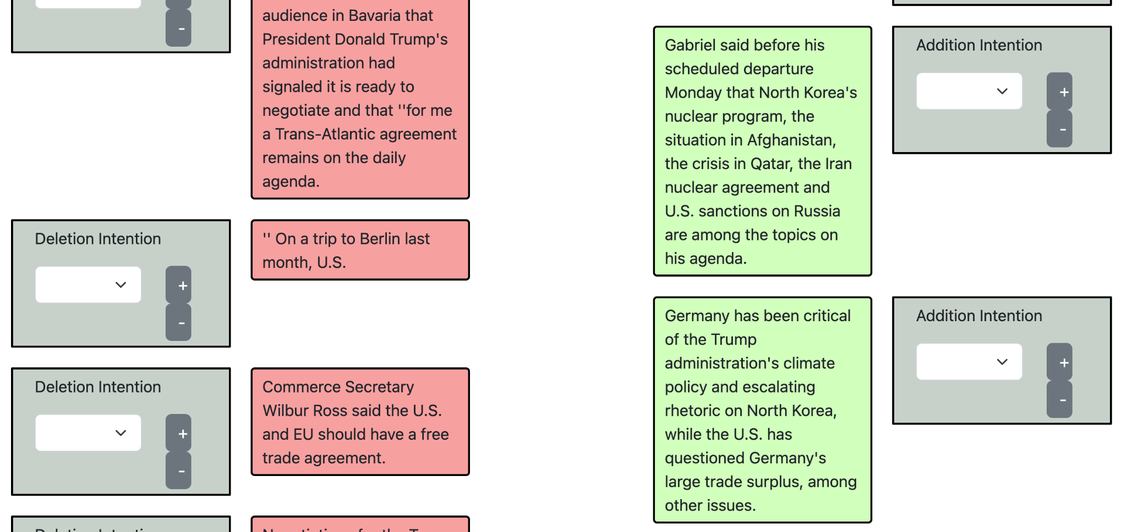

```||| Germany has been critical of the Trump administration's climate policy and escalating rhetoric on North Korea, while the U.S. has questioned Germany's large trade surplus, among other issues.```

##### Explanation:

This edit is a <b>Document Update</b> because no quote or event is added or updated. This is also an <b>Background</b> because the quote itself can be viewed as new information introduced and the information is not analytical.

#### Example:

http://localhost:5002/check_task?source=ap&doc_id=767&v_x=1&v_y=2

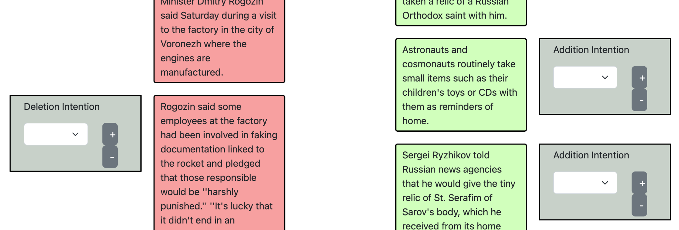

```||| Astronauts and cosmonauts routinely take small items such as their children's toys or CDs with them as reminders of home.```

##### Explanation:

This edit is a <b>Document Update</b> because no quote or event is added or updated. This is also an <b>Elaboration - Background</b> because the quote itself can be viewed as new information introduced and the information is not analytical.